4.6. Franck-Condon Vibronic Representation of the Carbonyl Emission Channel
To determine whether the predicted disease-associated spectral redistribution depended on representing oxidative-emission channels with smooth empirical line shapes, an effective Franck-Condon vibronic model was introduced for the triplet-excited carbonyl contribution. The calculation was not intended to assign infection-associated UPE to a single molecular species. Instead, it provided a structurally distinct molecular representation in which vibronic progression arises from displacement between ground- and excited-state potential-energy surfaces. Because the specific carbonyl products generated during infection-associated lipid peroxidation have not been uniquely identified, the calculation was treated as an effective structural model rather than a molecule-specific spectroscopic assignment.
The nominal model used a 0-0 transition energy of 2.75 eV, an effective vibrational spacing of 0.17 eV, a Huang-Rhys factor S = 1.2, and Gaussian broadening of 0.07 eV (Table 7). These parameters generated a broadened effective carbonyl-emission envelope with dominant intensity near 480 nm, within the spectral region associated with triplet-excited carbonyl emission. The resulting vibronic progression and broadened basis function are shown in Figure 10, and the first five transitions are summarized in Table 8.
Table 7. Nominal parameters of the effective Franck-Condon carbonyl model.
Parameter | Nominal value | Role
0-0 transition energy, E00 | 2.75 eV | Electronic origin of the effective carbonyl transition
Effective vibrational spacing | 0.17 eV | Spacing of the vibronic progression
Huang-Rhys factor, S | 1.2 | Controls relative vibronic intensities
Gaussian broadening | 0.07 eV | Represents unresolved homogeneous/inhomogeneous broadening
Effective peak wavelength | ~480 nm | Resulting dominant carbonyl-like emission region

Table 8. Nominal Franck-Condon vibronic progression.
n | Transition energy (eV) | Transition wavelength (nm) | Relative Franck-Condon weight
0 | 2.750 | 450.9 | 0.301
1 | 2.580 | 480.6 | 0.361
2 | 2.410 | 514.5 | 0.217
3 | 2.240 | 553.5 | 0.087
4 | 2.070 | 599.0 | 0.026

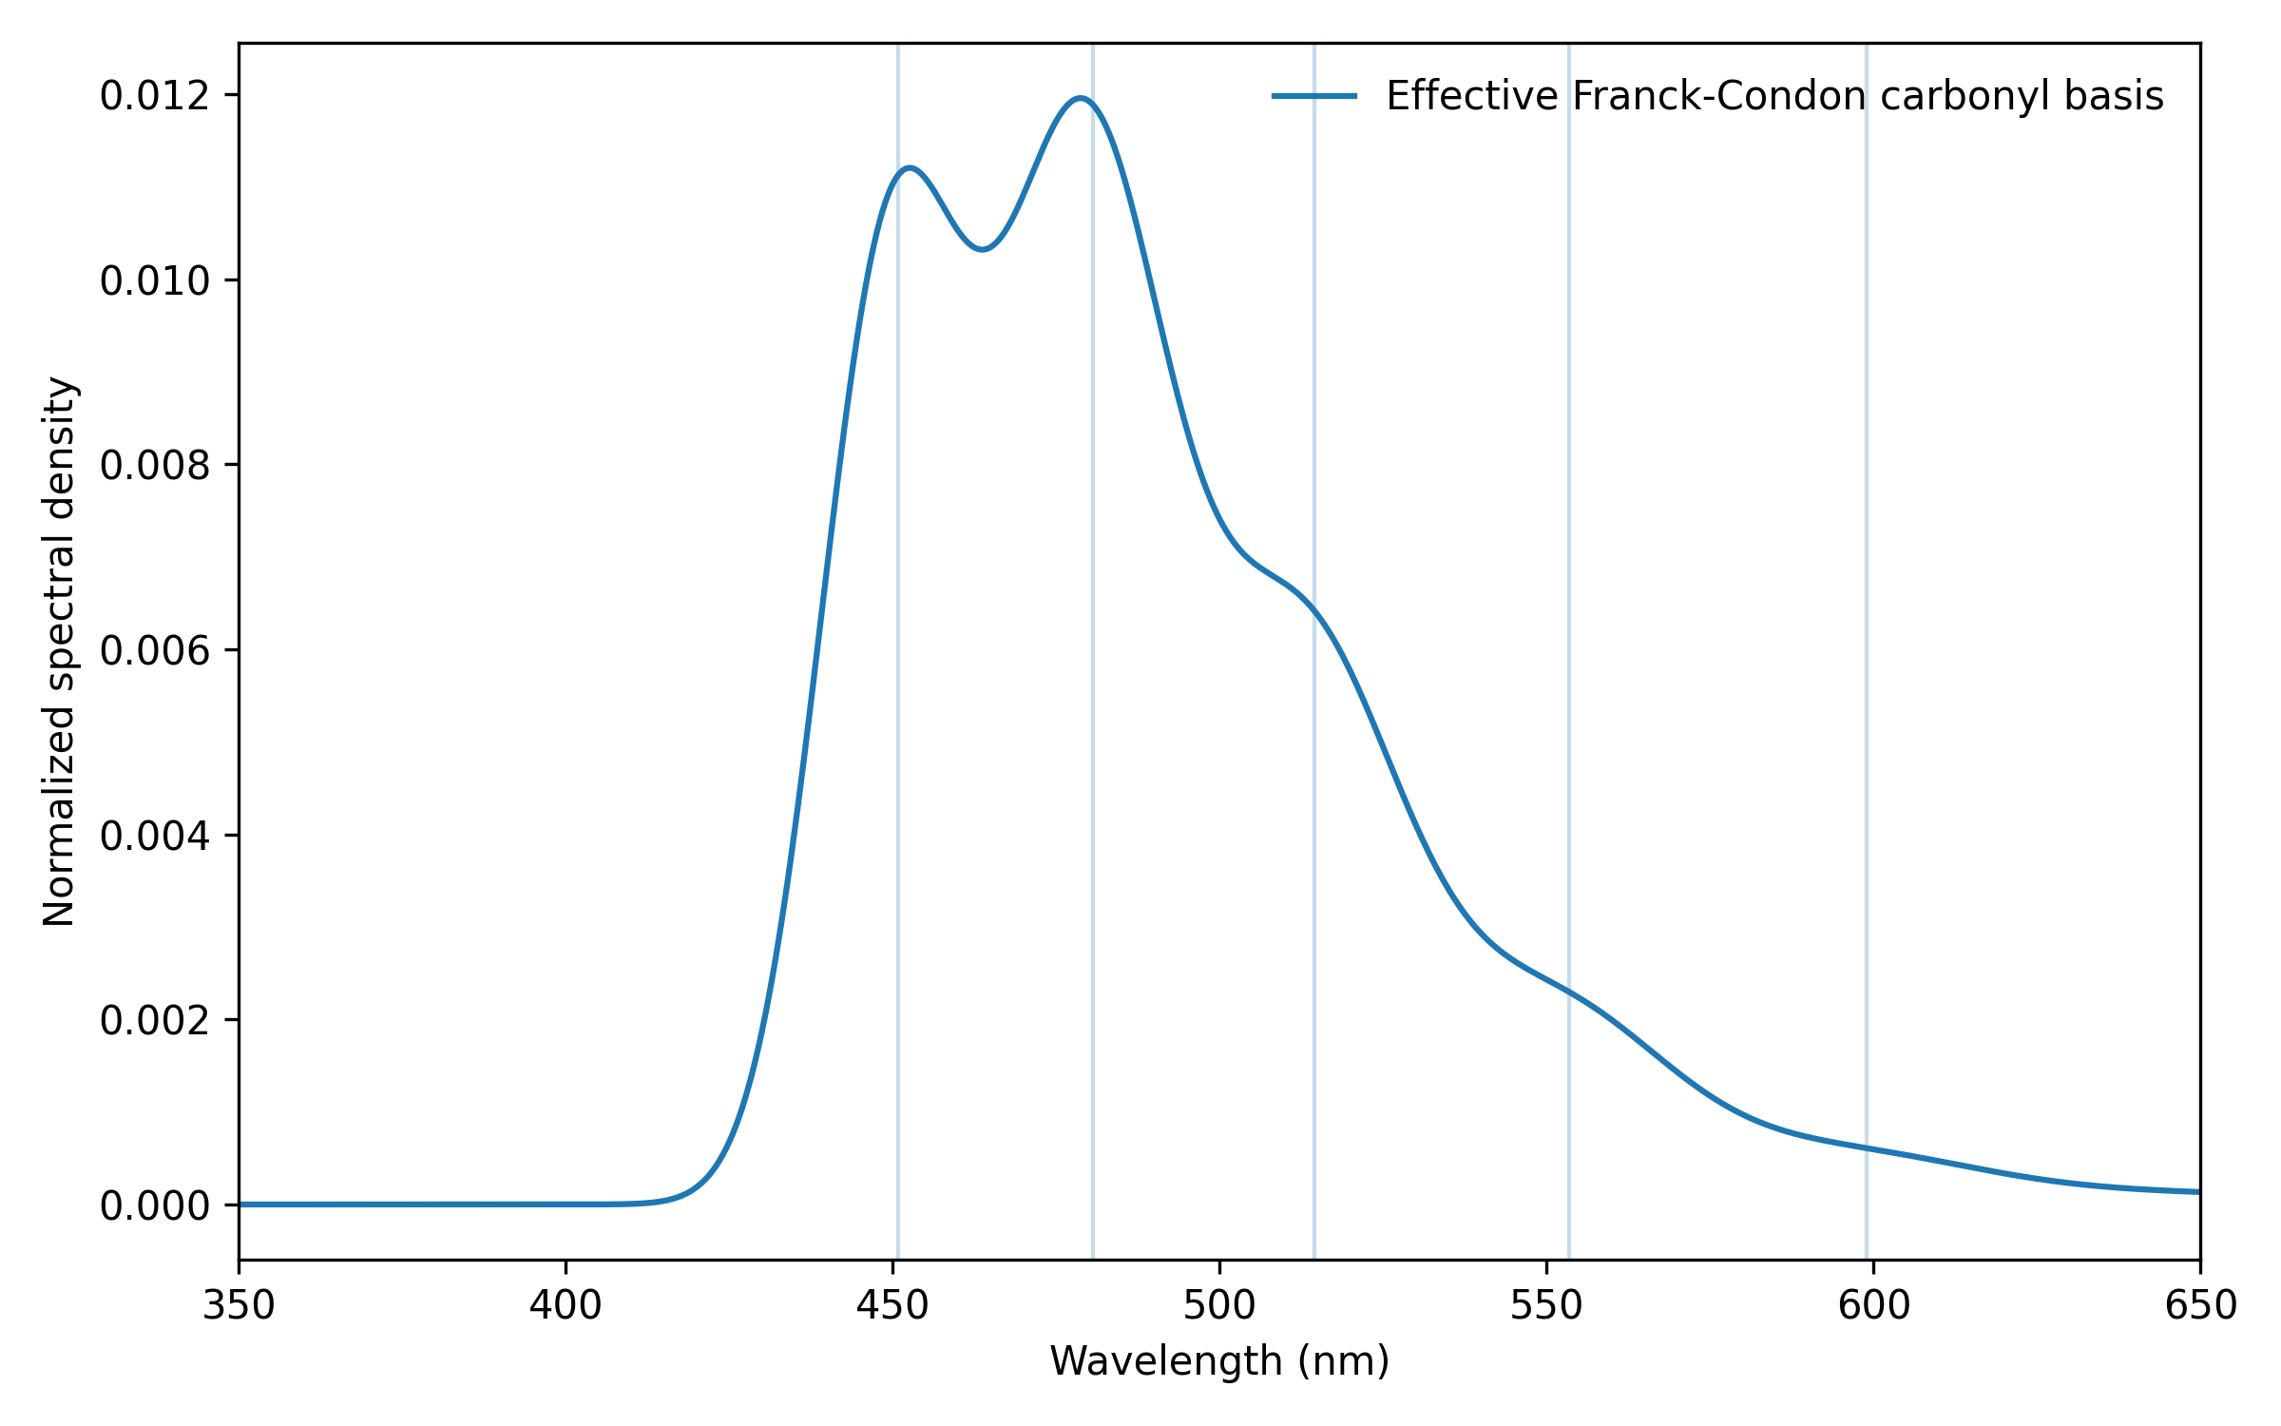
Figure 10. Effective Franck-Condon vibronic basis for the triplet-carbonyl-like emission channel. Vertical markers indicate the first several vibronic transition energies. The spectrum is an effective structural representation and is not assigned to a unique infection-specific carbonyl species.
When the Franck-Condon carbonyl basis was incorporated into the multichannel spectral model, the healthy spectral centroid was 528.51 nm, increasing to 571.68 nm for severe COVID-19 and 591.48 nm for sepsis (Figure 11; Table 9). Relative to healthy, these values corresponded to centroid displacements of +43.16 nm for COVID-19 and +62.97 nm for sepsis. The red-to-blue photon-yield ratio showed the same disease ordering, increasing from 0.197 in healthy to 0.449 for COVID-19 and 0.600 for sepsis; the corresponding disease-associated increases were +0.252 and +0.403, respectively.
Table 9. Franck-Condon carbonyl-hybrid spectral outputs.
Condition | Centroid (nm) | Red-to-blue ratio | Peak wavelength (nm)
Healthy | 528.51 | 0.197 | 480.0
COVID-19 | 571.68 | 0.449 | 480.5
Sepsis | 591.48 | 0.600 | 633.5

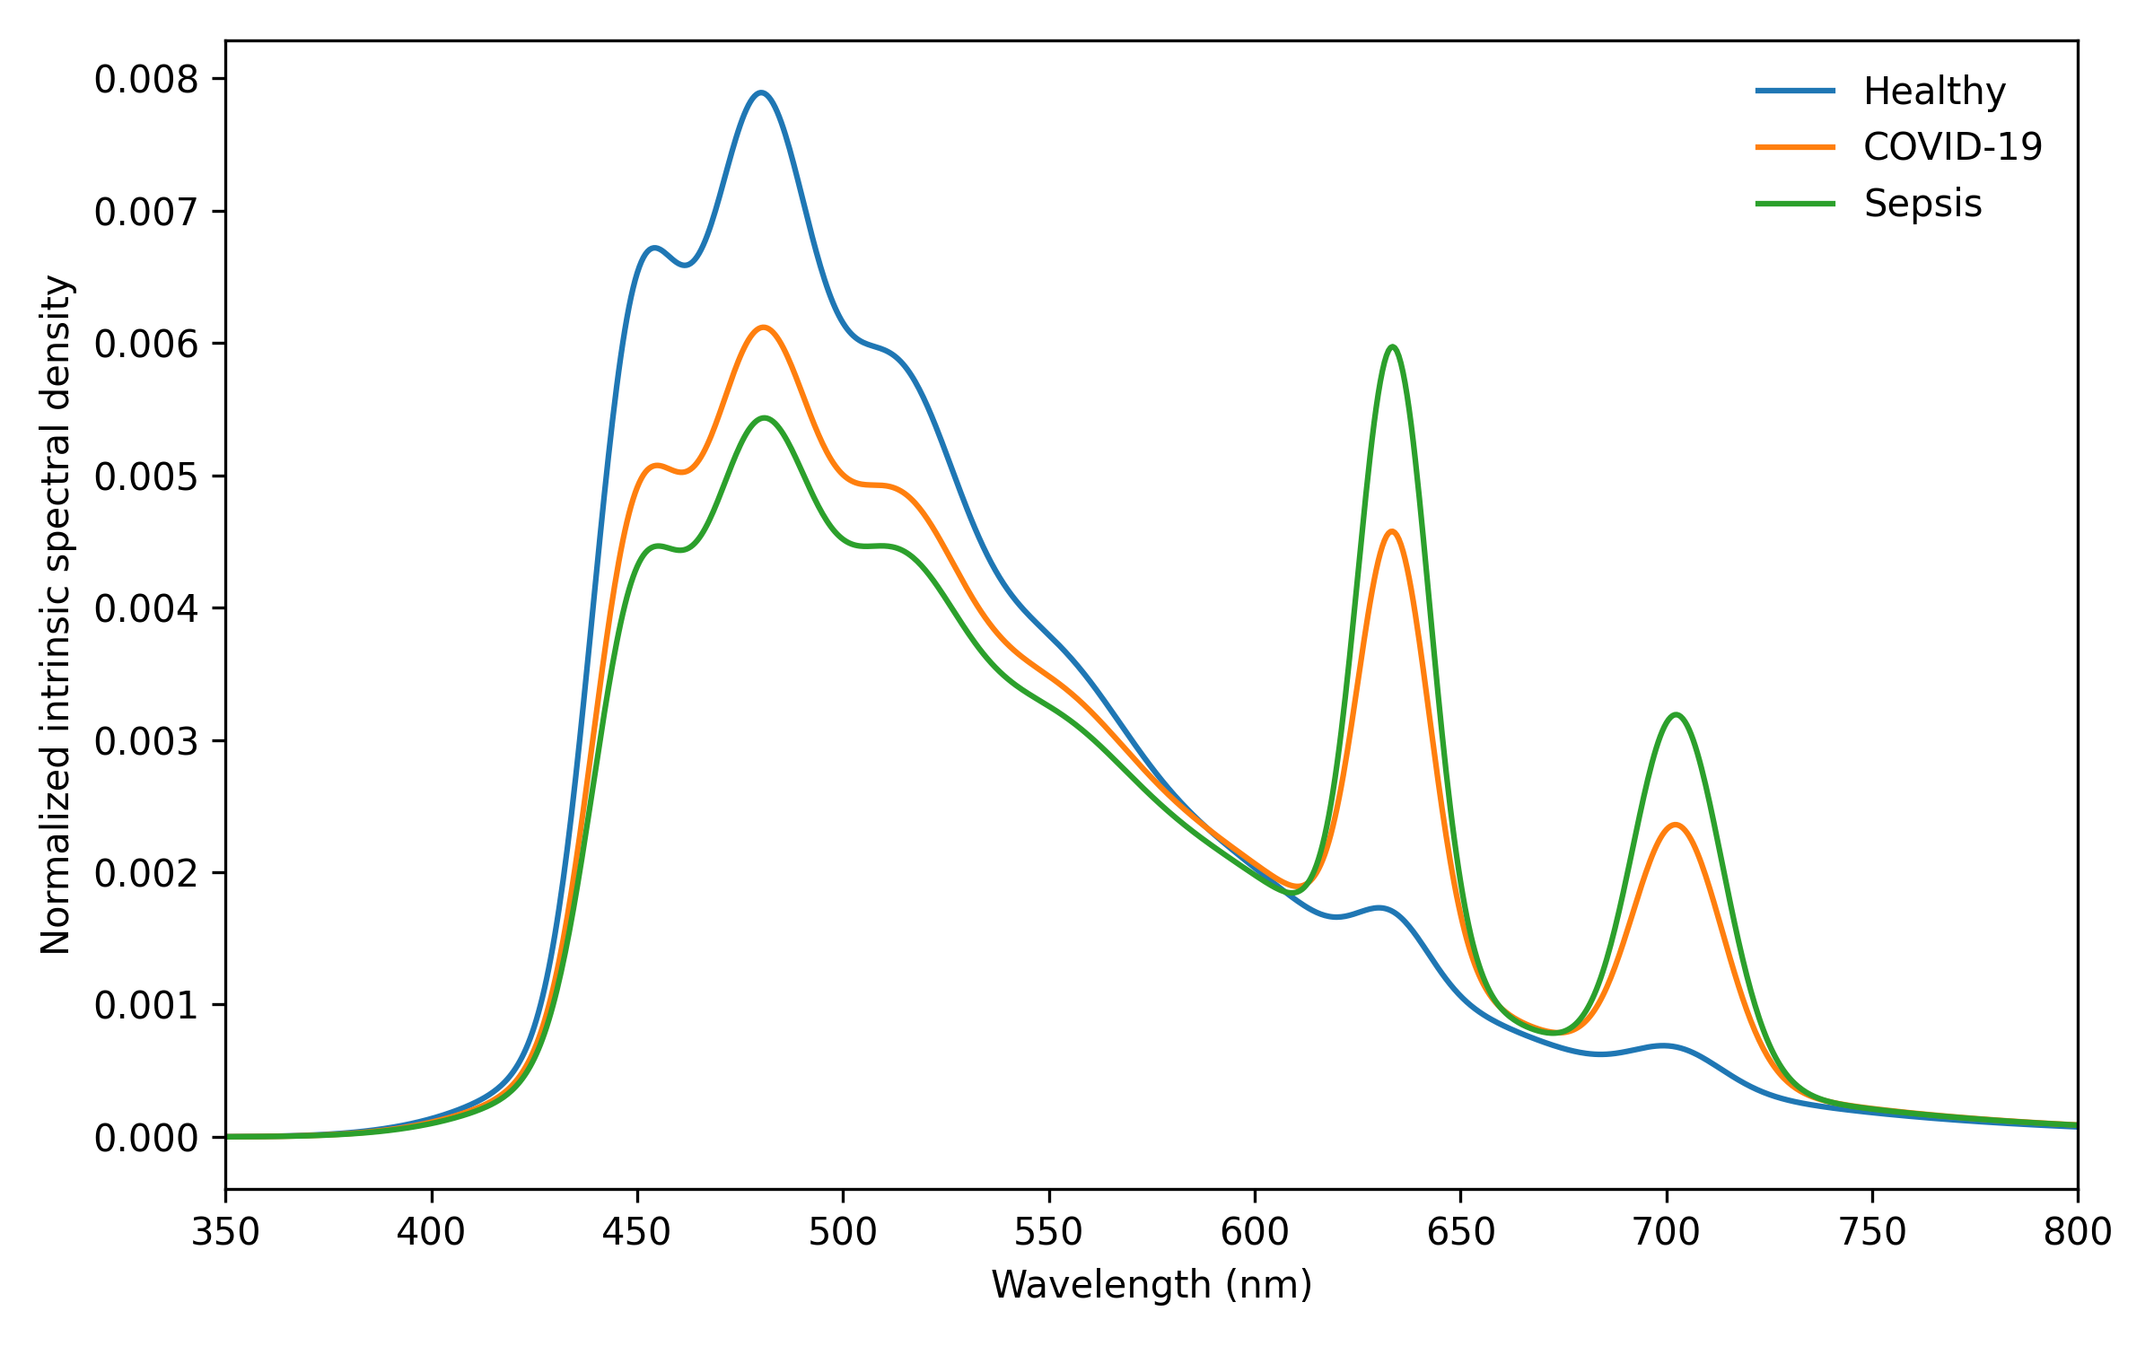
Figure 11. Disease-associated spectra predicted by the Franck-Condon carbonyl hybrid. The model preserves progressive redistribution toward longer-wavelength contributions from healthy to severe COVID-19 to sepsis without changing the intrinsic transition wavelengths of the modeled emitters.
The Franck-Condon representation reproduced the principal qualitative behavior observed with the Voigt, Gaussian, log-normal, and Tsuchida empirical-basis models. Although absolute centroid values differed among the alternative spectral formulations, every model predicted greater relative long-wavelength contribution with increasing oxidative burden. The Franck-Condon COVID-19 centroid displacement of 43.16 nm was close to the approximately 44-45 nm displacement predicted by the analytic models, while the sepsis displacement of 62.97 nm was similarly close to their approximately 65 nm values. The five-model comparison is summarized in Table 10 and Figures 12 and 13.
Table 10. Disease-minus-healthy spectral changes across five structural models.
Spectral model | COVID Δ centroid (nm) | Sepsis Δ centroid (nm) | COVID Δ red/blue | Sepsis Δ red/blue
Voigt | 44.63 | 64.96 | 0.253 | 0.404
Gaussian | 45.00 | 65.69 | 0.260 | 0.414
Log-normal | 44.45 | 64.61 | 0.278 | 0.441
Tsuchida empirical hybrid | 37.49 | 55.24 | 0.316 | 0.502
Franck-Condon hybrid | 43.16 | 62.97 | 0.252 | 0.403

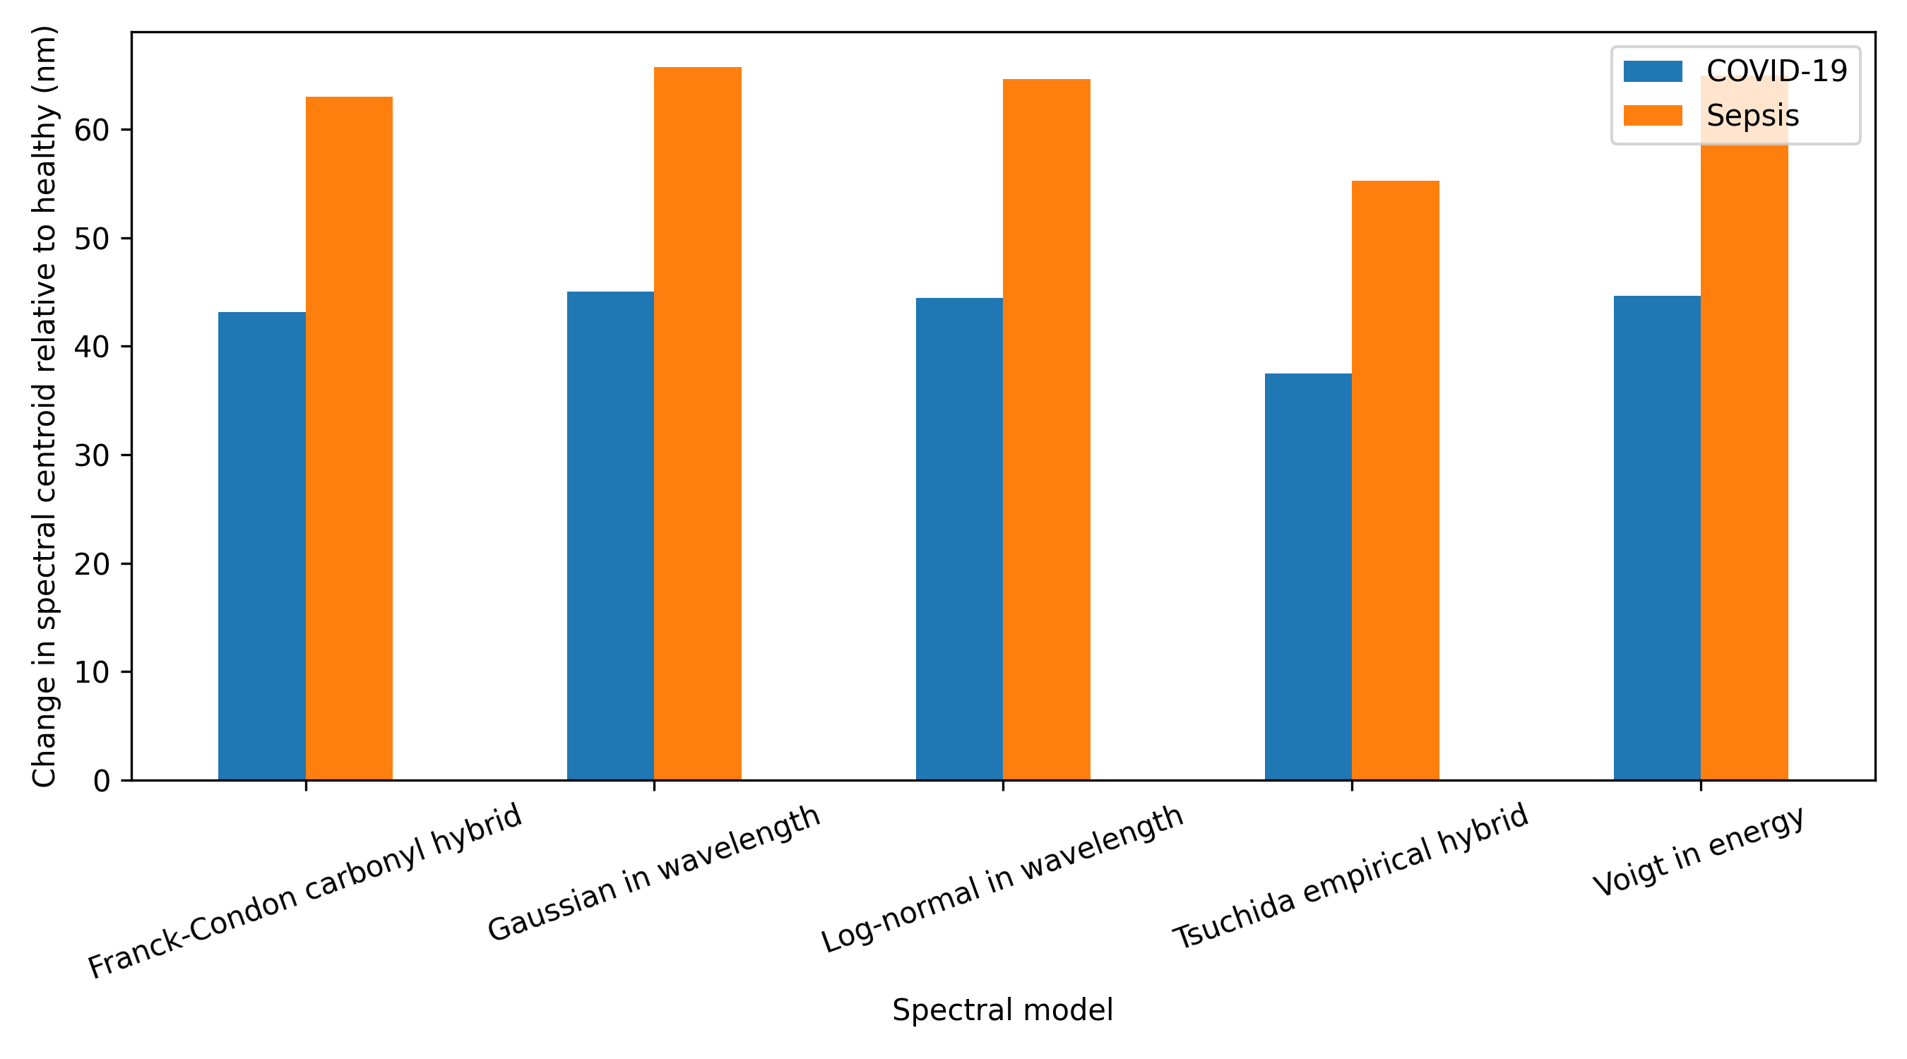
Figure 12. Disease-minus-healthy spectral-centroid displacement across five spectral structures. All tested structures preserve a positive centroid displacement for both disease conditions, although the magnitude remains model dependent.
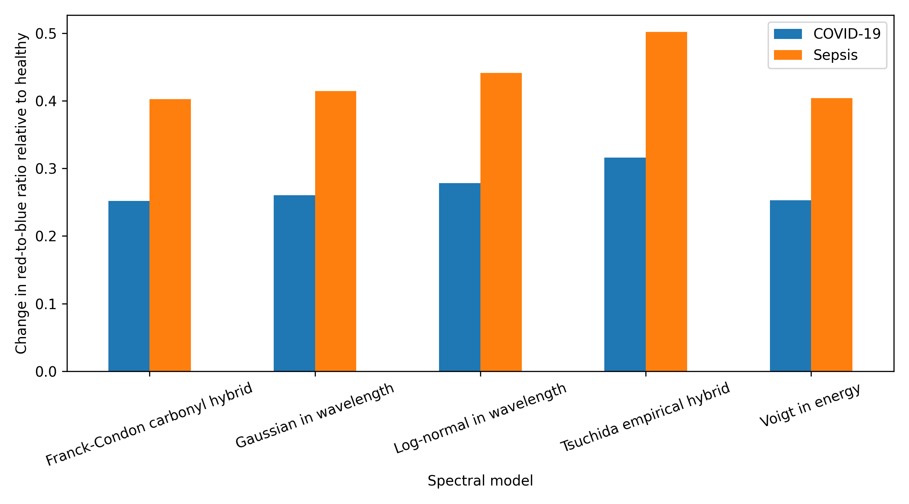
Figure 13. Disease-minus-healthy change in red-to-blue photon-yield ratio across five spectral structures. All five structures preserve an increased relative contribution from longer-wavelength emission in severe COVID-19 and sepsis.
To test whether the nominal Franck-Condon result depended strongly on a single vibronic parameter set, an exploratory structural sensitivity analysis was performed over 135 admissible parameter combinations per disease condition. The grid varied the 0-0 transition energy, effective vibrational spacing, Huang-Rhys factor, and broadening while retaining effective carbonyl spectra within the predefined physically plausible emission domain. Across all retained parameter sets, both disease conditions preserved a positive centroid displacement relative to healthy and an increase in the red-to-blue photon-yield ratio. The COVID-19 centroid displacement ranged from 39.38 to 49.04 nm, whereas the sepsis displacement ranged from 57.84 to 70.94 nm (Table 11).
Table 11. Exploratory robustness of the Franck-Condon structural prediction.
Condition | Parameter sets | Positive Δ centroid | Median Δ centroid (nm) | Range Δ centroid (nm) | Positive Δ red/blue | Median Δ red/blue | Range Δ red/blue
COVID-19 | 135 | 100.0% | 44.80 | 39.38-49.04 | 100.0% | 0.247 | 0.241-0.271
Sepsis | 135 | 100.0% | 65.19 | 57.84-70.94 | 100.0% | 0.395 | 0.386-0.433

The preservation of the sign of the redistribution throughout the admissible Franck-Condon parameter grid provides additional evidence that the direction of the predicted spectral change is structurally robust to uncertainty in the vibronic representation. This should not be interpreted as a statistical probability for real biological systems, because the parameter grid was not sampled from experimentally measured infection-specific molecular distributions.
Importantly, the Franck-Condon result does not identify a particular infection-derived carbonyl species. It addresses a narrower mechanistic question: whether introduction of a vibronically structured molecular-emission channel changes the qualitative spectral conclusions obtained from simpler analytic and empirical line-shape representations. The persistence of the healthy < COVID-19 < sepsis ordering in spectral centroid and red-to-blue photon yield indicates that it does not. Together with the analytic and experimentally derived basis-spectrum analyses in Section 4.5, the Franck-Condon calculation strengthens the conclusion that the predicted disease-associated spectral redistribution is more robust than the exact absolute spectral metrics used to quantify it.

